**ASSIGNMENT-4**

**FUNDAMENTAL OF MACHINE LEARNING**

**NAME-** MUTTA DATTA SAI VISHNU MOHAN

**USN-** 22BTRAD026

**QUES.** Load a dataset with outliers values (Boston Housing Dataset).

CODE:

import pandas as pd

# Load the Boston Housing dataset

boston_housing = pd.read_csv('HousingData.csv')

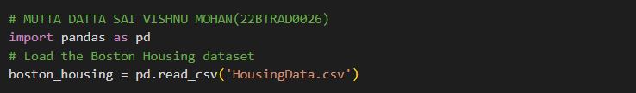

**QUES.** Implement one-hot encoding

CODE:

import pandas as pd

# Load the Boston Housing dataset

boston_housing = pd.read_csv('HousingData.csv')

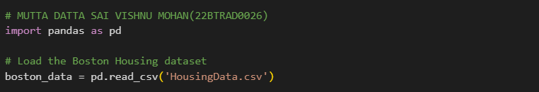

**QUES.** Create visualizations for different aspects of a dataset using Matplotlib or Seaborn.

**CODE:**

import matplotlib.pyplot as plt

# Scatter plot of MEDV vs RM

plt.scatter(boston_housing['RM'], boston_housing['MEDV'])

plt.xlabel('RM')

plt.ylabel('MEDV')

plt.show()

# Scatter plot of MEDV vs CRIM

plt.scatter(boston_housing['CRIM'], boston_housing['MEDV'])

plt.xlabel('CRIM')

plt.ylabel('MEDV')

plt.show()

# Scatter plot of MEDV vs LSTAT

plt.scatter(boston_housing['LSTAT'], boston_housing['MEDV'])

plt.xlabel('LSTAT')

plt.ylabel('MEDV')

plt.show()

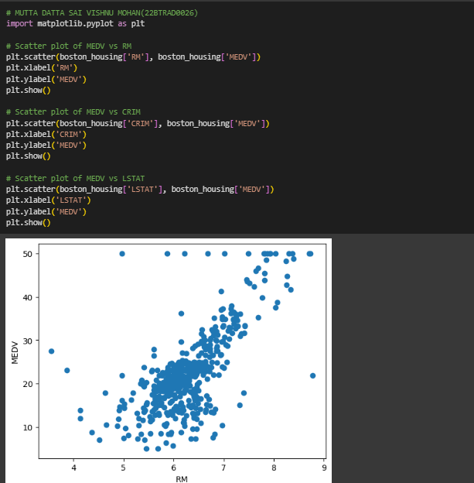

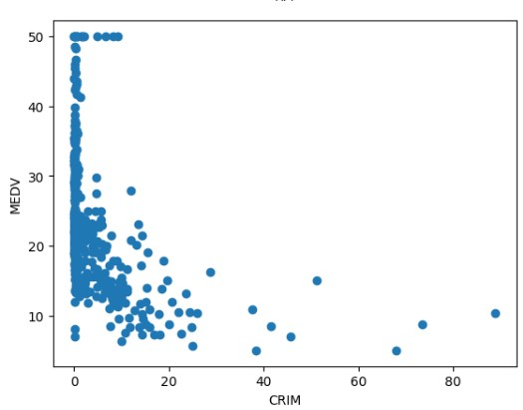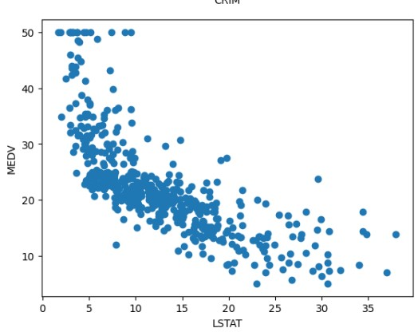

**QUES.** Interpret the visualizations to gain insights into the dataset.

CODE:

# Histogram of MEDV

plt.hist(boston_housing['MEDV'])

plt.xlabel('MEDV')

plt.ylabel('Frequency')

plt.show()

# Histogram of RM

plt.hist(boston_housing['RM'])

plt.xlabel('RM')

plt.ylabel('Frequency')

plt.show()

# Histogram of CRIM

plt.hist(boston_housing['CRIM'])

plt.xlabel('CRIM')

plt.ylabel('Frequency')

plt.show()

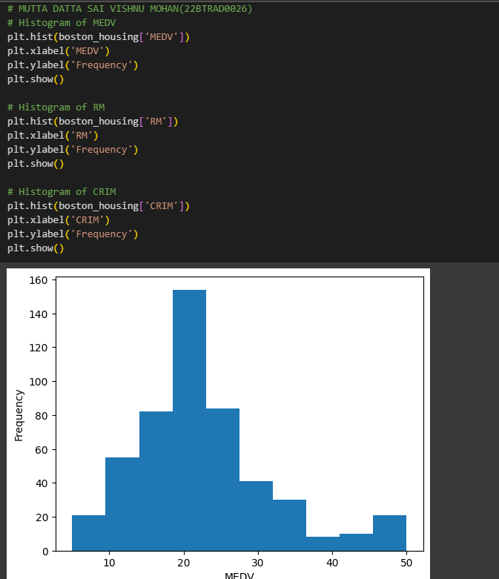

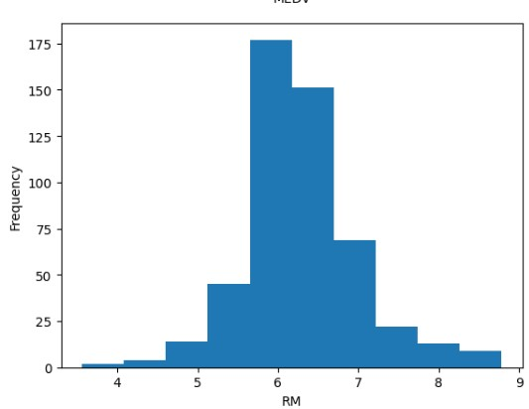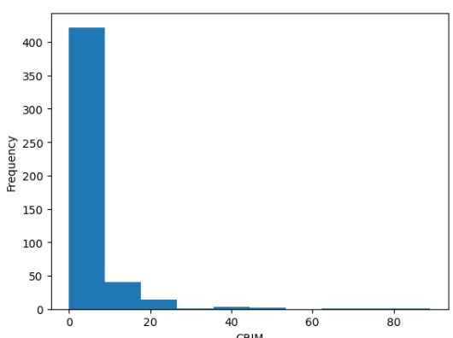

**QUES.** Perform Univariate and multivariate analysis for the dataset.

CODE:

import seaborn as sns

plt.figure(figsize=(10, 8))

sns.histplot(boston_housing['AGE'], kde=True, bins=30)

plt.title('Distribution of AGE')

plt.xlabel('Age')

plt.show()

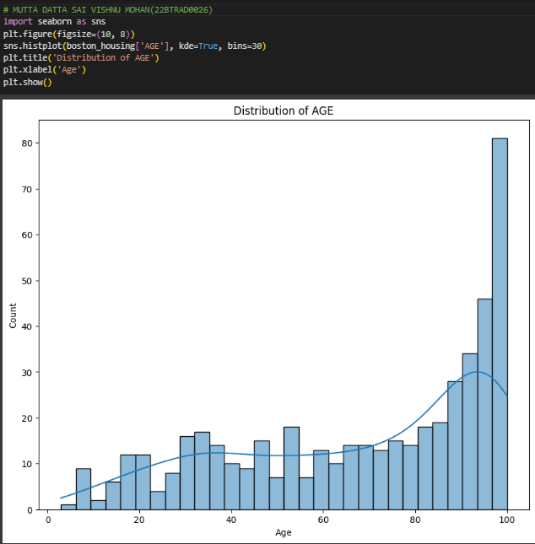

GITHUB:

https://github.com/MDSVISHNUMOHAN/MACHINE-LEARNING